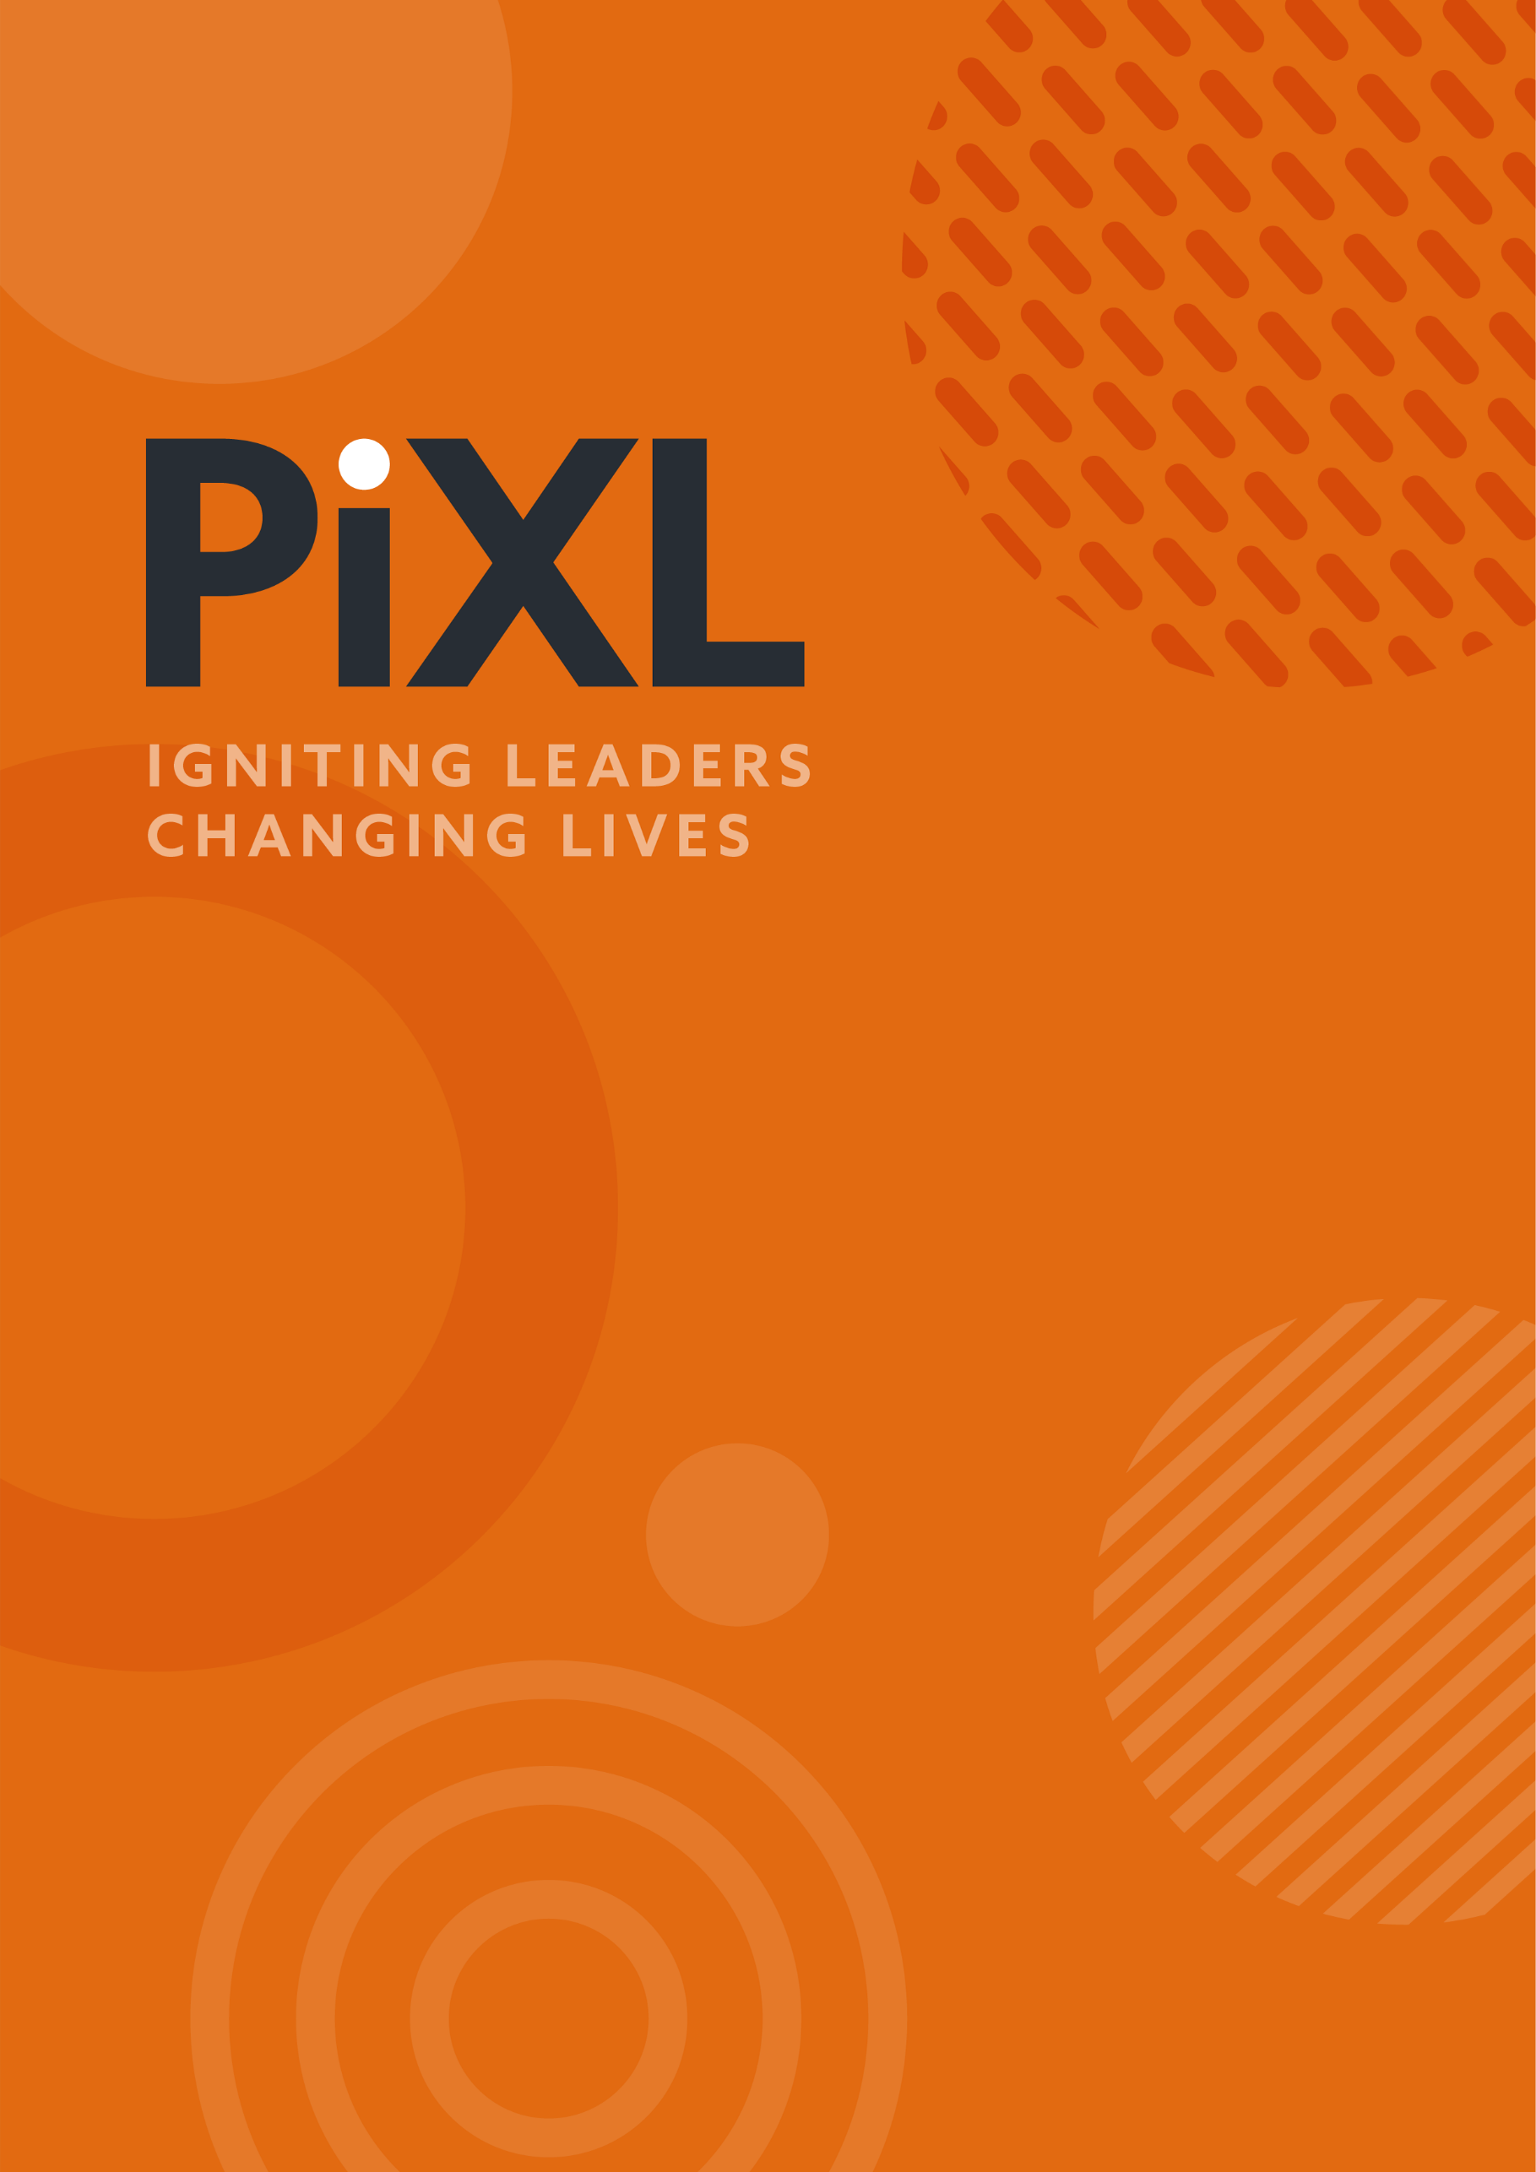

PARENT GUIDE TO PHONICS IN PRIMARY SCHOOLS

Starting with phonics is crucial as it teaches children how to sound out and pronounce words correctly. However, reading isn’t just about being able to say the words; it’s also about understanding what those words mean together, which is known as comprehension. Comprehension turns reading from just a skill into an enjoyable and meaningful activity.
But just knowing how to read words doesn’t mean a child will instantly understand what they’re reading. Comprehension requires a deeper engagement with the text. To help with this, we focus on fluency, which is the ability to read smoothly and with expression. Being fluent makes reading more enjoyable and helps children understand the story or information better.
As children become better at reading without stopping to figure out each word, we introduce strategies to help them understand and think about what they’re reading. These strategies include guessing what might happen next, picturing the story in their minds, asking questions about the text, and summarising what they’ve read. This helps them not just read but engage with the text on a deeper level.
Beyond understanding the text, we want to encourage a love for reading. This means letting children choose books that interest them and are at the right level for their abilities. We’ll guide you on how to find books that will not only hold your child’s attention but also connect with their experiences, making reading more enjoyable for them.
We also suggest ways to make reading a fun part of your family’s daily life. This can involve setting up a special reading area, having a regular time for reading together, and doing activities related to the books. Our goal is to create a positive reading environment at home where stories are enjoyed and a love for reading is developed.

PHONICS: A GUIDE FOR PARENTS
Supporting your child's reading development is a collaborative effort between what they learn at school and how this is reinforced at home. A fundamental part of learning to read is understanding phonics and developing decoding skills.
Phonics is a teaching method that focuses on the relationship between sounds and the letters that represent them. It's a vital part of learning to read and write because it helps children understand how words are built and how to decode them.
At its core, phonics teaches children that the English language is made up of small, manageable units of sound, known as phonemes. By recognising these sounds and the letters or groups of letters (graphemes) that represent them, children can begin to read and spell words.

WHY PHONICS MATTERS
Supports Reading Development: Phonics is key to developing reading skills. It enables children to break down words into sounds, which they can then blend together to read words they may not have seen before.

Aids in Spelling: As children learn that letters represent sounds, they also learn to spell by thinking about the sounds in a word and choosing the letters that represent those sounds.

Builds Confidence: Being able to read and spell words accurately boosts children's confidence in their reading ability. This confidence encourages them to read more widely and enjoy a variety of books.

Enhances Comprehension: Phonics instruction also contributes to comprehension. As children spend less time decoding each word, they can focus more on understanding the text as a whole.

Foundation for Lifelong Learning: Strong reading skills are essential for success across all subjects in school and for lifelong learning. Phonics provides children with the tools they need to tackle new and challenging words, fostering independence in reading and learning.

Phonics is a critical step in your child's educational journey, offering them the skills they need to become proficient readers and writers. As parents, understanding and supporting this aspect of their learning can make a significant difference in their academic success and love of reading.

SUPPORTING PHONICS AT HOME
As a parent, you play a vital role in reinforcing and supporting the phonics skills your child learns at school. Here are some effective ways to do this:

- Reading Together: Regularly read with your child, pointing out phonics patterns and sounds in words as you come across them. This can be as simple as identifying the sound a letter makes at the beginning of a word or blending sounds together to read a new word.

- Phonics Games and Activities: Engage your child in phonics-based games and activities that reinforce their learning in a fun and interactive way. There are many online resources, apps, and board games designed to support phonics learning. Activities like letter-sound matching, word building with magnetic letters, and phonics flashcards can be both educational and entertaining.

- Encourage Writing: Encourage your child to write, applying their phonics knowledge. This could involve writing letters, words, or even short sentences about their day or a story they’ve imagined. Focus on the sounds in words and the letters that represent these sounds.

- Use Phonics Resources: Utilise phonics resources provided by school, such as worksheets, reading books aligned with their phonics programme, and online resources. These materials are specifically designed to complement what your child is learning in class.

- Positive Reinforcement: Celebrate your child’s successes and efforts in reading and writing. Positive reinforcement boosts their confidence and motivation to continue learning and practising.

- Communicate with Teachers: Stay in regular communication with your child’s teachers to understand where your child is in their phonics learning and to receive advice on how best to support them at home.

- Create a Literacy-rich Environment: Surround your child with a variety of reading materials, including books, magazines, and labels. A literacy-rich environment not only supports phonics learning but also encourages a love of reading.



© The PiXL Club Ltd. 2024. All Rights Reserved.
This resource is strictly for the use of The PiXL Club (“PiXL”) subscribing schools and their students for as long as they remain PiXL subscribers. It may NOT be copied, sold, or transferred to or by a third party or used by the school after the school subscription ceases. Until such time it may be freely used within the PiXL subscribing school by their teachers and authorised staff and any other use or sale thereof is strictly prohibited.
All opinions and contributions are those of the authors. The contents of this resource are not connected with, or endorsed by, any other company, organisation or institution.
This resource may contain third party copyright material not owned by PiXL and as such is protected by law. Any such copyright material used by PiXL is either provided under licence or pending a licence.
PiXL endeavour to trace and contact third party copyright owners. If there are any inadvertent omissions or errors in the acknowledgements or usage, this is unintended and PiXL will remedy these on written notification.

