Red Nose Day Drawing Competition!
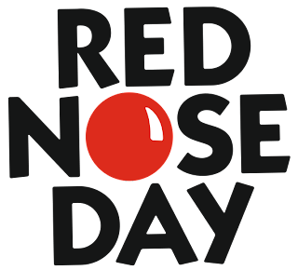

For Red Nose Day this year, we are going to be holding a drawing competition for the whole school to enter. The artwork needs to be done at home and be no bigger than A4. You are welcome to use any type of medium you would like. Once completed please bring in the entry fee and artwork to Miss Stewart or Miss Bishop. There will be a prize for 3rd, 2nd and 1st Place. Winners will be announced in Assembly on Monday.

Theme: Something Red
Entry Fee: 50p
Deadline for Entries: Friday 17th March 2023

