**Knowledge Organiser – Forces and Magnets**

|  |  |
| --- | --- |
| **Key Vocabulary** | **Definition** |
| Force | A push or a pull. |
| Contact force | A force where objects need to touch each other to push or pull. |
| Non-contact force | A force where objects do not have to touch each other to push or pull. |
| Magnetic force | A force between magnets. |
| Magnet | A material that produces a magnetic field. |
| Attract | To pull together. |
| Repel | To push away. |
| Magnetic pole | Where the magnetic field is strongest. |

Examples of contact force

Friction is the force which acts in the direction opposite to the motion.

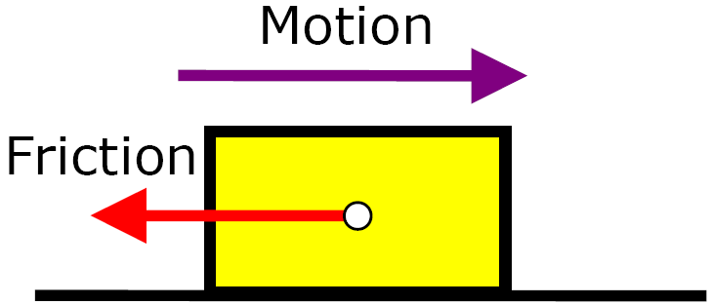

Applied force (push)

Tension (pull)

Friction

Air resistance

Friction always slows a moving object down.

Friction always slows a moving object down.

Water resistance

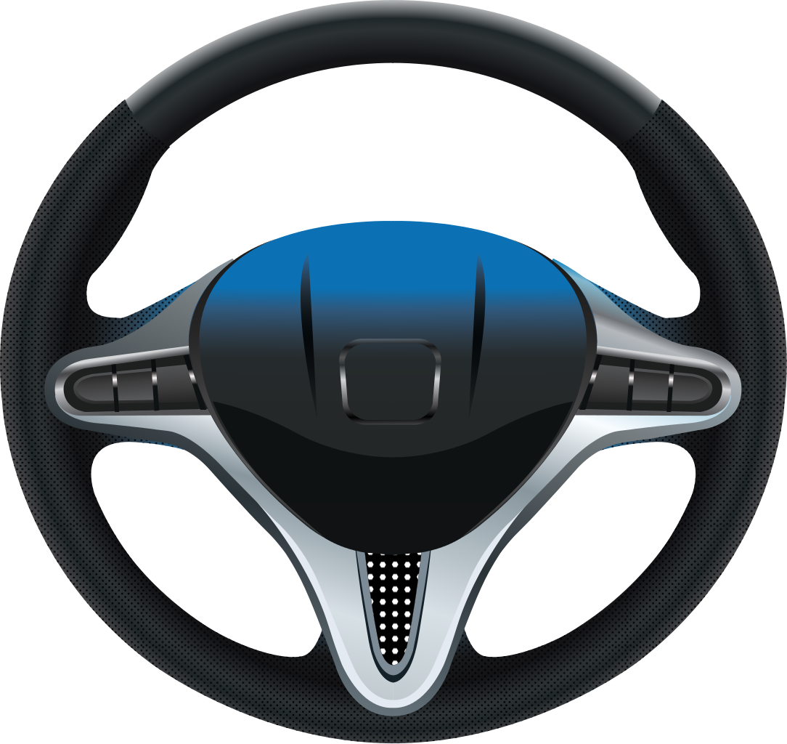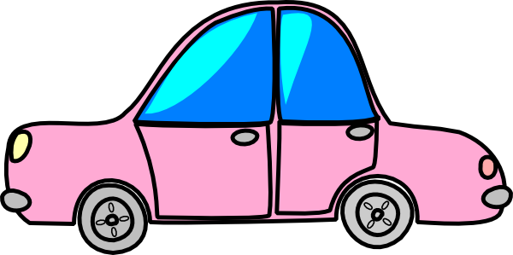

Spring force (twist)

Examples of non-contact force

Gravity

Less force is needed to move the car on smooth surfaces (it is easier to move).

The force needed to move the car is greater on rough surfaces (so it is harder to move).

Magnetic force

Static Electricity

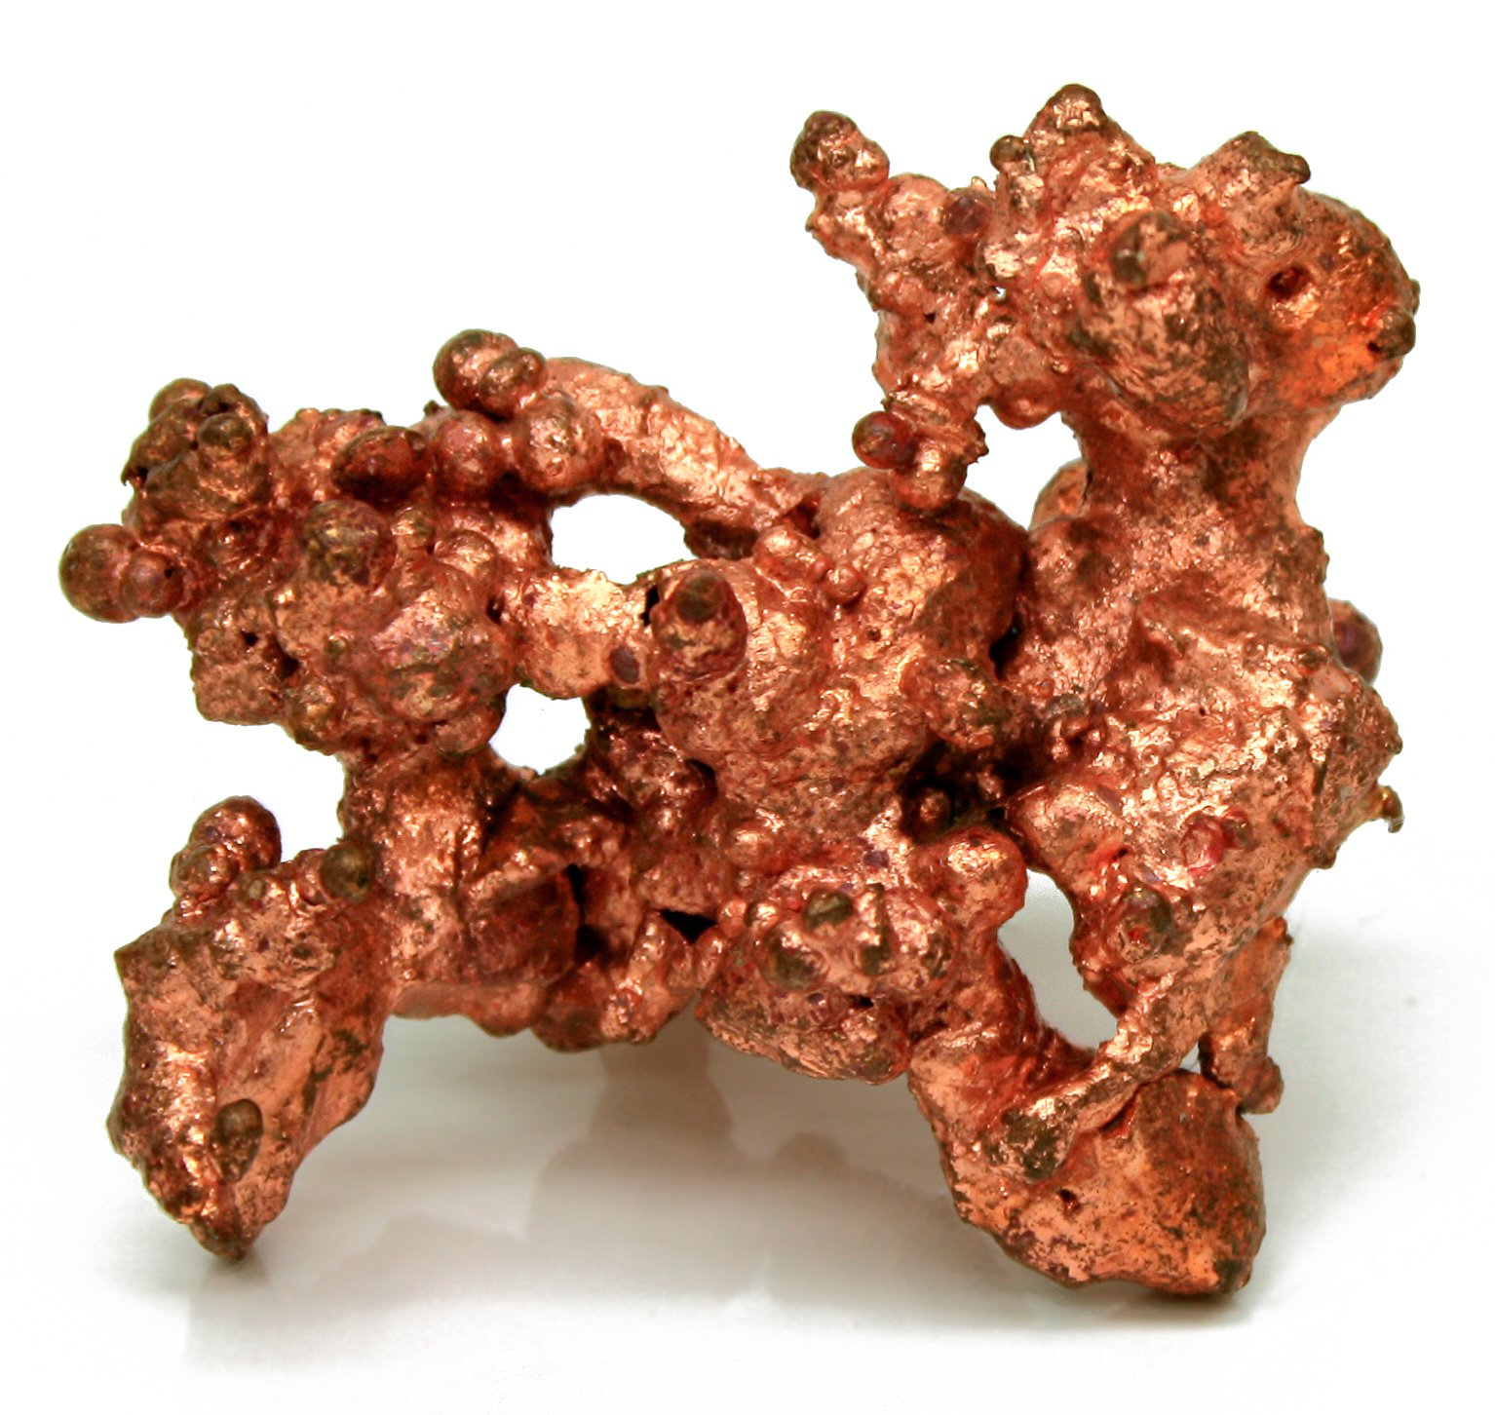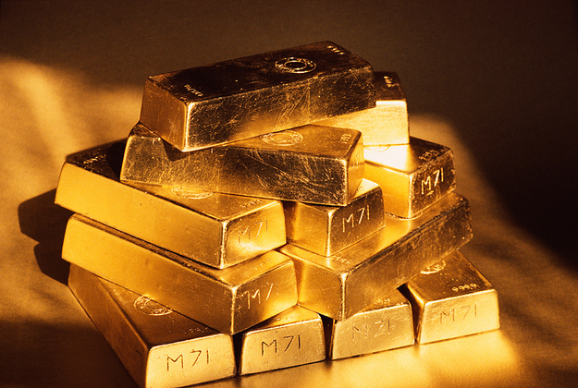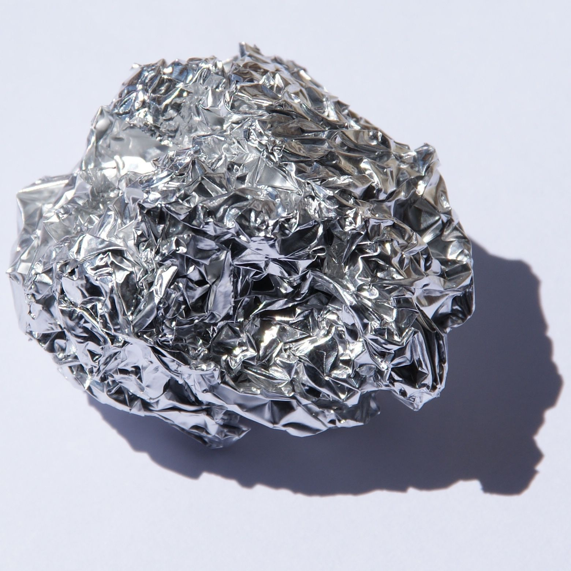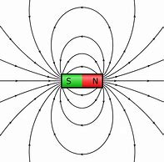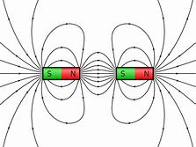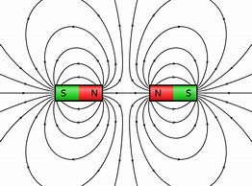 

Gold

Steel contains iron so it will be magnetic.

Non-magnetic materials

Copper

Iron

Cobalt

Magnets produce an area of magnetic force called a magnetic field.

south pole

magnetic field

north

pole

Aluminium

Nickel

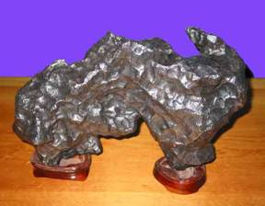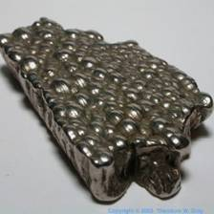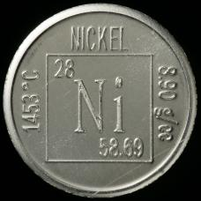

Magnetic materials

If a north pole is next to the south pole, then the field lines go straight from the north pole to the south pole.

Attract

If north poles or south poles face each other, field lines move away from each other.

Repel

Vitamins and minerals