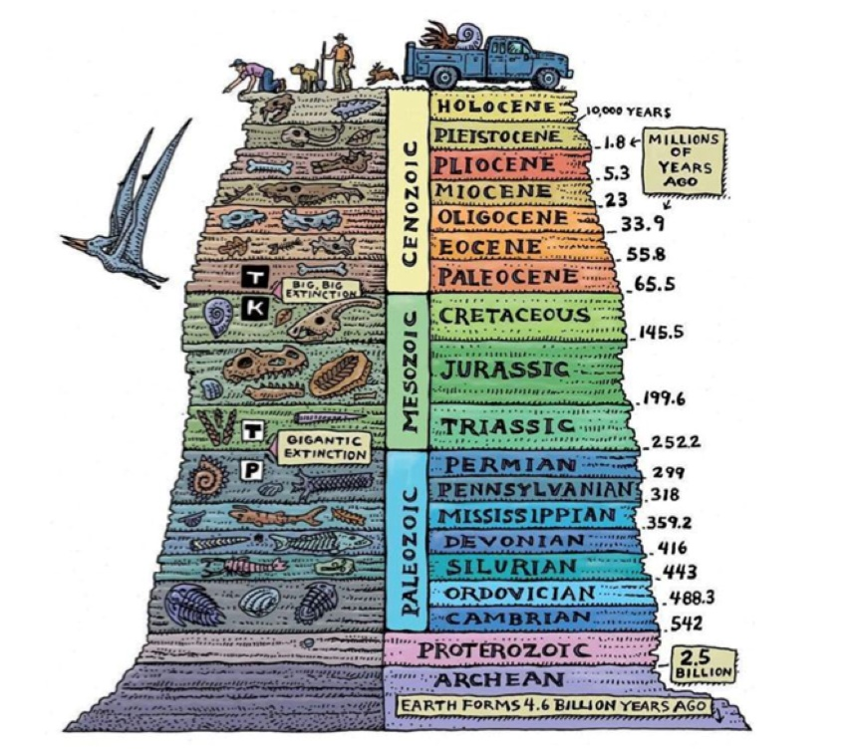
Knowledge Organiser – Evolution (Science Year 6)
Key Vocabulary | Definition
Evolution | Gradual process in which something changes.
Adaptation | Process of changing.
Characteristics | Qualities that make things different to other things.
Variation | A difference or change.
Inheritance | Passing of characteristics from parents to offspring.

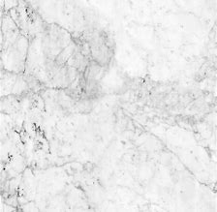
Fossils are formed over millions of years and they are trapped in layers of rock.
We can use these layers to find out how old the fossils are and how species have changed over time.
Larger crystals that interlock.
Marble

Similarities and differences between fossils in rocks of different ages help us to see how animals have evolved over billions of years.

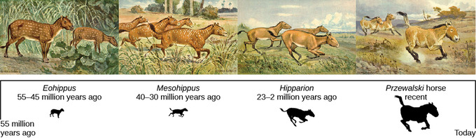
A four-toed hoof evolved into a single hoof, more suitable for running.
A modern-day horse is much taller than its original ancestor.

Variation - Within a species, there are natural variations, mutations, that result from differences in the genetic material.
Why do species change over time?
When living things reproduce, they pass on characteristics to their offspring.
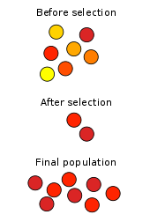
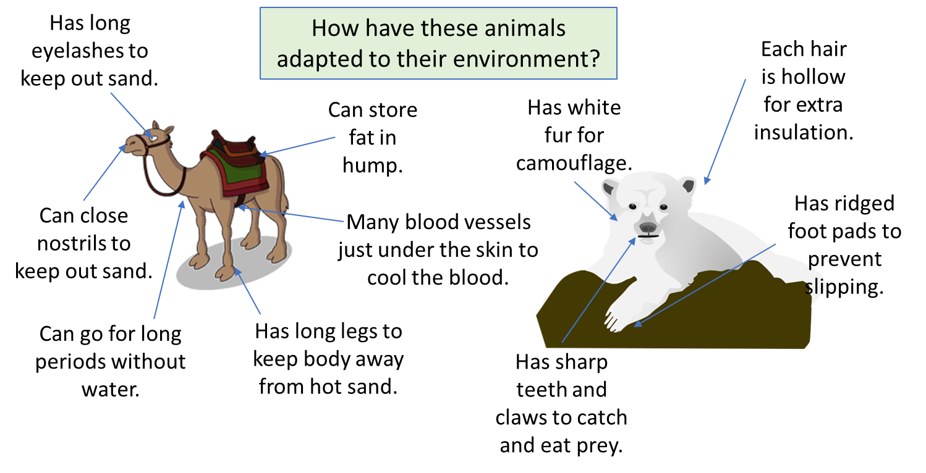
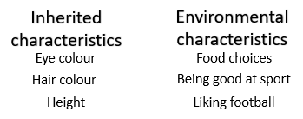
Selection - Organisms with particularly advantageous adaptations are most likely to survive long enough to reproduce.
Adaptation - Sometimes a mutation occurs that makes an individual more able to survive than other members of the group.
When offspring have similar characteristics to their parents, we say that they are inherited.

